COINS-Constantine I (306-337)-AE3-Camp Gate- Cyzicus

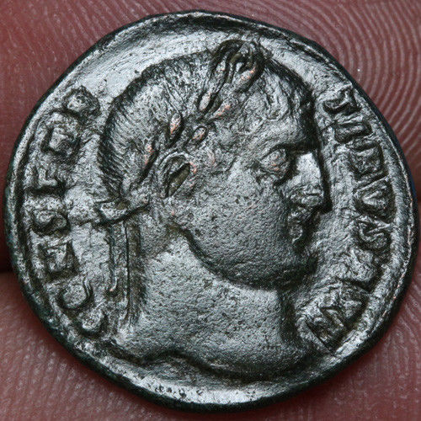 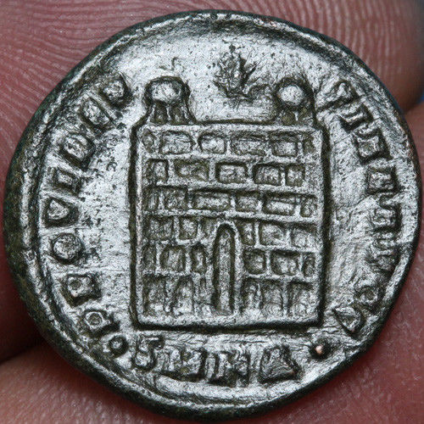

**Roman coin AE follis Constantine I 307-337 AD CAMP GATE Cyzicus** 27.87413 40.38981

**20mm , 2.9grams**

